10: Perform Git Version Control Operations

AIM:
To learn and perform basic Git version control operations such as cloning a repository, adding files, committing changes, creating branches, and merging branches.

Procedure / Algorithm:
- Install Git
  - Download Git from https://git-scm.com.
  - Verify installation using git --version.
- Clone Repository
  - Go to GitHub repository page.
  - Click the Code button → select HTTPS → copy URL.
  - Run git clone REPO_URL.
- Add Files and Commit
  - Create or copy files into the repository folder.
  - Stage files using git add filename.
  - Commit changes using git commit -m "message".
  - Push changes using git push origin main.
- Create Branch
  - Run git branch branch-name.
  - Switch using git checkout branch-name.
- Merge Branch
  - Switch back to main using git checkout main.
  - Merge changes using git merge branch-name.

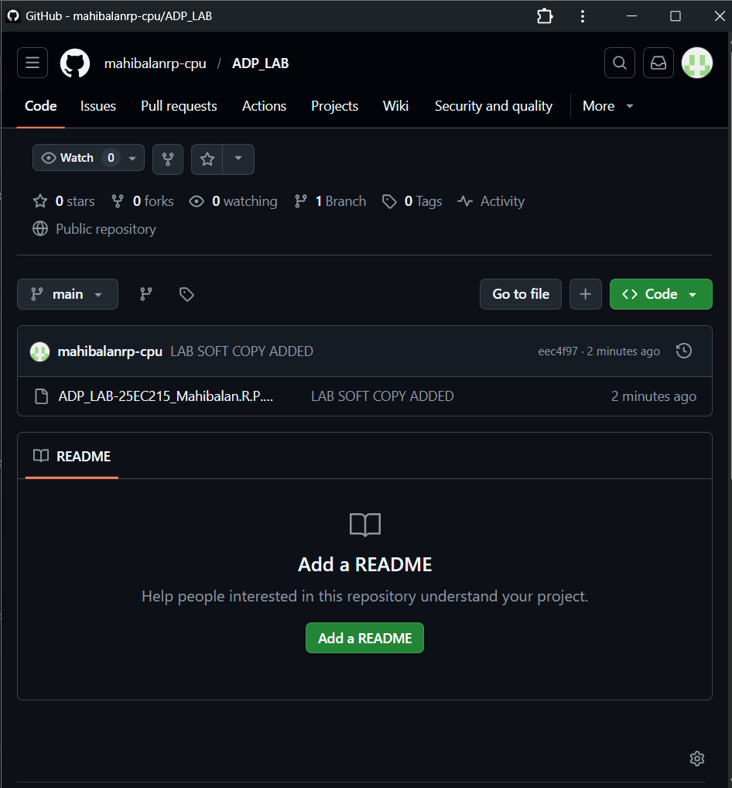
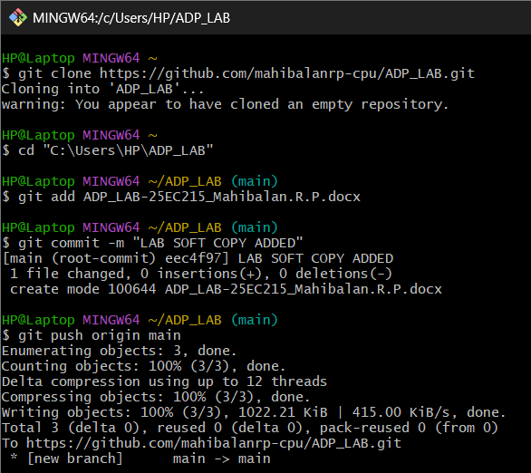
Coding and Output:

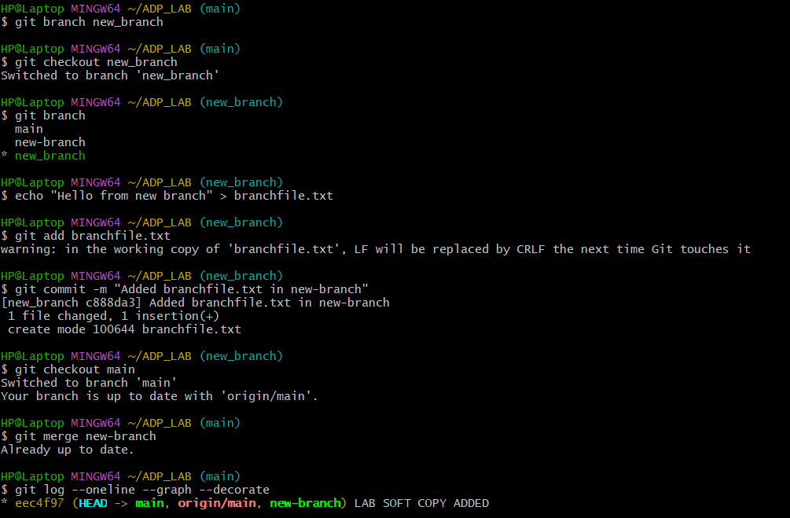

Result:
The basic Git version control operations were successfully performed.
- Git was installed and verified using git --version.
- A remote repository was cloned locally using git clone.
- Files were added, committed, and pushed to the remote repository.
- A new branch was created with git branch and switched using git checkout.
- Changes made in the new branch were merged back into the main branch using git merge.
- The commit history confirmed the merge with a merge commit message.

